**DAILY ONLINE ACTIVITIES SUMMARY**

|  |  |  |  |  |  |  |  |  |
| --- | --- | --- | --- | --- | --- | --- | --- | --- |
| **Date:** | **26/05/2020** | | | | | **Name:** | **NAIPUNYA VINOD NAIK** | |
| **Sem & Sec** | **IV SEM & A SECTION** | | | | | **USN:** | **4AL18CS050** | |
| **Online Test Summary** | | | | | | | | |
| **Subject** | | **DESIGN AND ANALYSIS OF ALGORITHMS** | | | | | | |
| **Max. Marks** | | **30** | | **Score** | | | **25** | |
| **Certification Course Summary** | | | | | | | | |
| **Course** | **JAVA PROGRAMMING** | | | | | | | |
| **Certificate Provider** | | | **GREAT LEARNING ACADEMY** | | **Duration** | | | **3.5 HRS** |
| **Coding Challenges** | | | | | | | | |
| **Problem Statement: 1)** [Write a program in C to print all permutations of a given string using pointers.](https://github.com/orgs/alvas-education-foundation/teams/2nd-year/discussions/81)  2) [Given an array A of size N where the array elements contain values from 1 to N with duplicates, the task is to find total number of sub arrays which start and end with the same element.](https://github.com/orgs/alvas-education-foundation/teams/2nd-year/discussions/80) | | | | | | | | |
| **Status: EXECUTED** | | | | | | | | |
| **Uploaded the report in Github** | | | | | **YES** | | | |
| **If yes Repository name** | | | | | <https://github.com/naipunya-naik/lockdown-coding/blob/master/C%20CODING/perrmutation%20of%20string.c>  <https://github.com/naipunya-naik/lockdown-coding/blob/master/JAVA%20CODING/same%20element.java> | | | |
| **Uploaded the report in slack** | | | | | **YES** | | | |

Online Test Details: (Attach the snapshot and briefly write the report for the same)

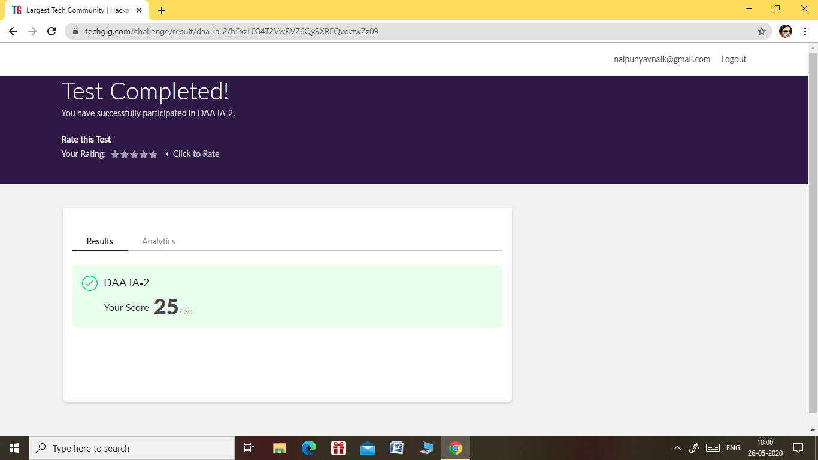

* THE 2ND I.A TEST OF DESIGN AND ANALYSIS ALGORITHMS WAS CONDUCTED ON 26th MAY 2020.
* SUBJECT:- DESIGN AND ANALYSIS OF ALGORITHMS
* TOTAL MARKS :- 30 MARKS
* DURATION:- 45 MIN
* NO.OF QUESTIONS:-30
* EACH QUESTION CARRIED 1 MARK

Certification Course Details: (Attach the snapshot and briefly write the report for the same)

CERTIFICATION COURSE NAME: JAVA PROGRAMMING

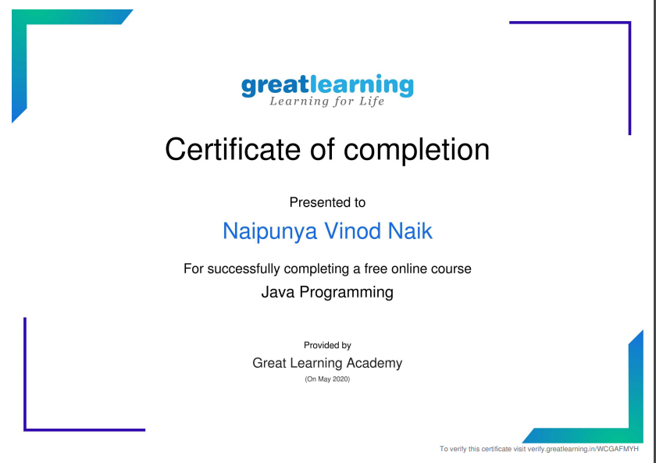

TOPICS LEARNT

* ARRAYS IN JAVA
* FUNCTIONS IN JAVA
* OBJECT ORIENTED PROGRAMMING IN JAVA
* COLLECTIONS IN JAVA
* INHERITANCE IN JAVA

Coding Challenges Details: (Attach the snapshot and briefly write the report for the same)

**PROBLEM STATEMENT 1:-**[**Write a program in C to print all permutations of a given string using pointers.**](https://github.com/orgs/alvas-education-foundation/teams/2nd-year/discussions/81)

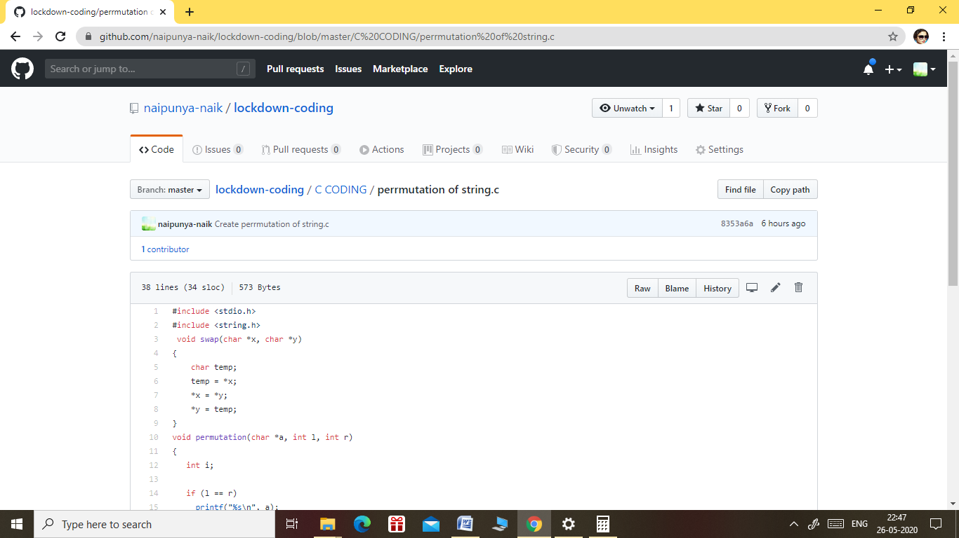

GITHUB REPOSITORY LINK:-

<https://github.com/naipunya-naik/lockdown-coding/blob/master/C%20CODING/perrmutation%20of%20string.c>

PROBLEM STATEMENT 2:-

[Given an array A of size N where the array elements contain values from 1 to N with duplicates, the task is to find total number of sub arrays which start and end with the same element.](https://github.com/orgs/alvas-education-foundation/teams/2nd-year/discussions/80)

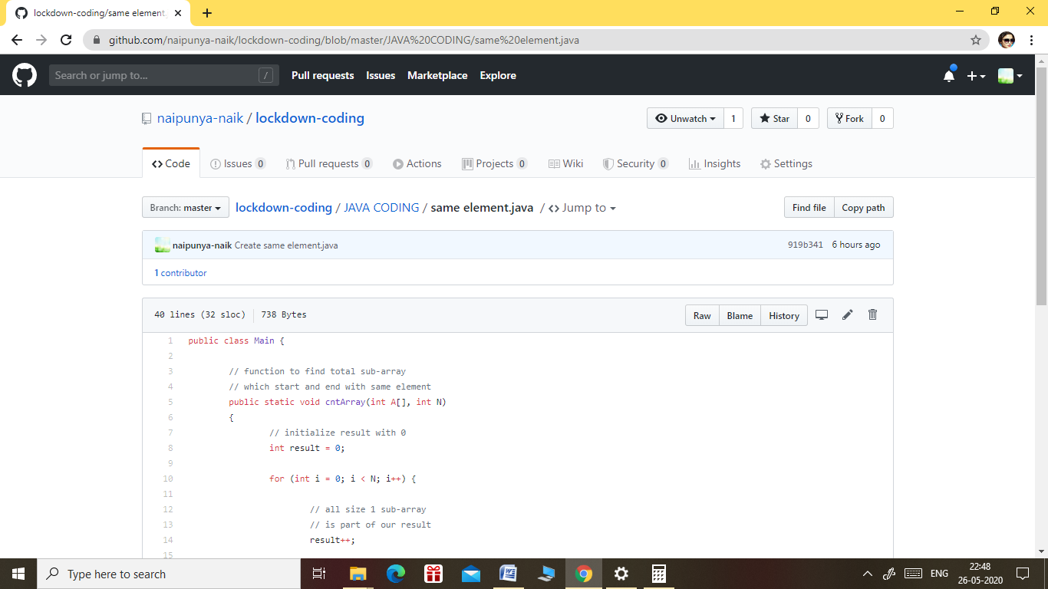

LINK IN GITHUB REPOSITORY :

<https://github.com/naipunya-naik/lockdown-coding/blob/master/JAVA%20CODING/same%20element.java>